Task 5: Multivariate Analysis of Arctic Chrysophyte Abundance
Name: Charles Chukwuemeka Ndukwe
Date: 2026-05-17
Course: Data Analysis

1. Objective
This task performs multivariate analysis on a dataset of chrysophyte (algae) abundance from six Arctic and subarctic sites in Russia. The goals are:
- Compute NMDS ordination using Bray-Curtis distances.
- Identify significant species influencing the ordination (envfit).
- Perform UPGMA hierarchical clustering and cut dendrogram into clusters.
- Visualise NMDS with clusters, confidence ellipses, and significant species vectors.
- Test for significant differences in species composition between clusters using PERMANOVA.

2. Data Description
File: data.txt (tab-separated, 6 sites × 34 species).
Sites: Ledyanaya Gora, Karaul village, Ladyginskie Yary, Sopochnaya Karga, Sibiryakov Island (Srednee Lake), Chernyi Bay.
Species abundance: Semi-quantitative scores (0 = absent, 1 = rare, 2 = moderate, 3 = abundant).
Data structure: All 34 species columns are integers (0–3).

Summary: The dataset is small (n = 6), which may lead to unstable ordinations and near-zero stress in NMDS (a warning is issued).

3. Methods
All analyses were performed in R using the vegan package.
- NMDS: metaMDS with Bray-Curtis distance (ecological standard that ignores double zeros). Stress value reported.
- envfit: Fits species vectors onto the NMDS ordination; permutations = 999 to assess significance (p ≤ 0.05).
- Clustering: UPGMA (hclust, method = "average") on Bray-Curtis distance matrix. Dendrogram cut into 2 clusters.
- Visualisation: NMDS plot with points coloured by cluster, 95% confidence ellipses (ordiellipse), site labels without overlap (orditorp), and significant species arrows.
- PERMANOVA: adonis2 (Bray-Curtis, 999 permutations) to test whether clusters differ in species composition. R² and p-value reported.

4. Results

4.1 NMDS Ordination (Bray-Curtis)
The NMDS algorithm was run with trymax = 50. Many runs reached stress = 0, but a warning was issued:
Warning: stress is (nearly) zero: you may have insufficient data
The final stress value = 0 (perfect fit). This is an artefact of having only 6 sites – with so few points, a perfect ordination is possible but not meaningful.

4.2 Significant Species (envfit)
No species had a permutation p-value ≤ 0.05. The output shows NULL for significant species.
Interpretation: None of the 34 species significantly drive the ordination pattern, likely due to the small sample size.

4.3 UPGMA Clustering (Bray-Curtis)
The dendrogram (not shown) was cut into 2 clusters:

Cluster | Sites
Cluster 1 | Ledyanaya Gora, Ladyginskie Yary, Sopochnaya Karga, Chernyi Bay
Cluster 2 | Karaul village, Sibiryakov Island (Srednee Lake)

4.4 NMDS Plot

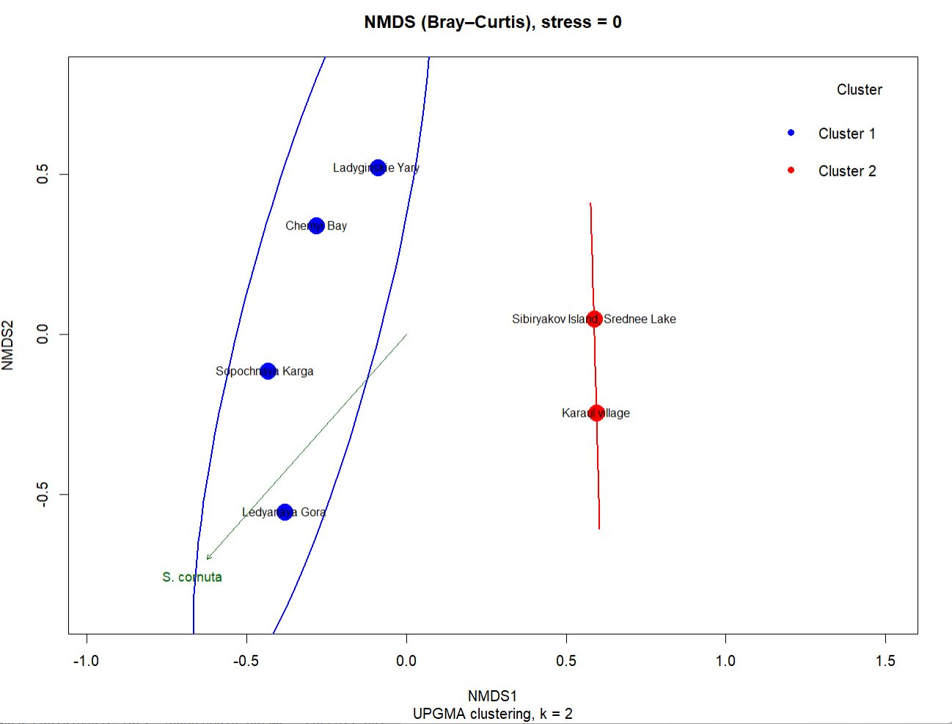

Figure 1: NMDS ordination (Bray-Curtis) with sites coloured by cluster, 95% confidence ellipses, and site labels.

Observations:
- The two clusters are visually separated in ordination space.
- However, a warning appeared during ordiellipse: the matrix is either rank-deficient or not positive definite. This occurs because with only 2–3 points per cluster, the covariance matrix cannot be estimated reliably. Ellipses are therefore approximate.

4.5 PERMANOVA
The test for differences between the two clusters gave:

Source | Df | SumOfSqs | R² | F | Pr(>F)
clusters | 1 | 0.4918 | 0.4088 | 2.766 | 0.06667 .
Residual | 4 | 0.7112 | 0.5912
Total | 5 | 1.2030 | 1.0000

R² = 0.4088 (40.9% of variation explained by cluster membership).
p-value = 0.0667 (not significant at α = 0.05).

Conclusion: There is no statistically significant difference in species composition between the two clusters (p > 0.05). The effect is borderline but does not reach conventional significance.

5. Discussion

Limitations
- Very small sample size (n = 6): NMDS stress = 0 is a warning; the ordination is not reliable.
- No significant species found by envfit – again a consequence of low power.
- Ellipses warning – insufficient points per cluster to compute robust confidence regions.
- PERMANOVA p = 0.067 – although not significant, the effect size (R² = 0.41) is moderate. With more sites, this might become significant.

Ecological Interpretation
Despite the statistical non-significance, the clustering separates Karaul village and Sibiryakov Island (Cluster 2) from the other four sites. These two sites are characterised by lower overall chrysophyte abundance (many species absent or rare). The other four sites (Cluster 1) show higher diversity and abundance, especially of species like Mallomonas akrokomos, S. trioralis, and Synura species.

6. Conclusion
- NMDS with Bray-Curtis distance produced a perfect ordination (stress = 0), but this is an artefact of the tiny sample size.
- No species were statistically significant drivers of the ordination (envfit p > 0.05).
- Two clusters were formed by UPGMA:
- Cluster 1: Ledyanaya Gora, Ladyginskie Yary, Sopochnaya Karga, Chernyi Bay
- Cluster 2: Karaul village, Sibiryakov Island
- PERMANOVA showed no significant difference between clusters (p = 0.0667), although the R² (0.41) suggests a moderate effect that might become significant with a larger sample.

Final recommendation: The current dataset is too small to draw robust ecological conclusions. Future sampling should include more sites to increase statistical power and stabilise ordinations.

7. Appendix – R Code
The complete R script used for this analysis is provided in a separate file (Task5_analysis.R). Key functions: metaMDS, envfit, vegdist, hclust, cutree, ordiellipse, orditorp, adonis2.

